Name : Saurabh Jadhav

Topic : S3 object versioning, CRR (Cross Region Replication) and SRR(Same Region Replication)

Assignment no. : 14

1. Create a S3 bucket with below configuration.
2. Bucket type as general purpose
3. Enable ACl permission

1. Provide public access.
2. Enable versioning.

1. Keep other config as default.
2. Click on create bucket.

1. Upload the file.
2. Create a new file with name file.txt

1. Upload the file and provide public permission to file. Click on upload

1. Check the versioning by editing the file.
2. Make changes to file.txt

1. Upload the file.txt again with public permission. Click on upload.

1. View the versions a file.txt

1. Create another version of file.txt with private permission.

It will not accessible due to private permission.

1. Recover the deleted file.txt
2. Delete the file.txt

1. It will delete the file but its version will be still available.

1. To recover, permanently delete the file type “delete marker”.

1. File is recovered.

1. CRR
2. Create a new bucket in Mumbai region.

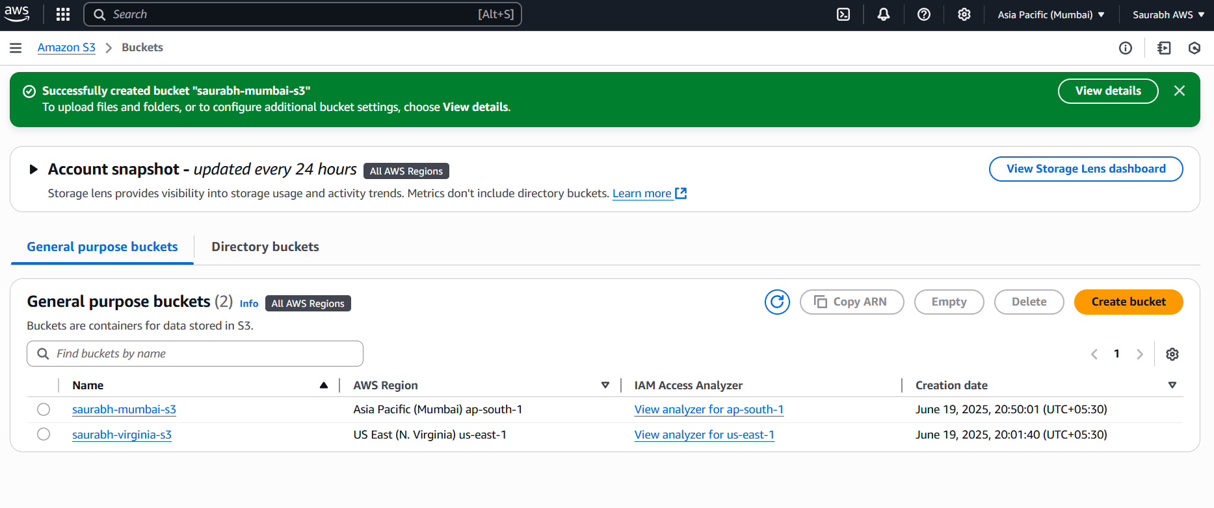

1. Navigate to Management tab for creating replication rule.

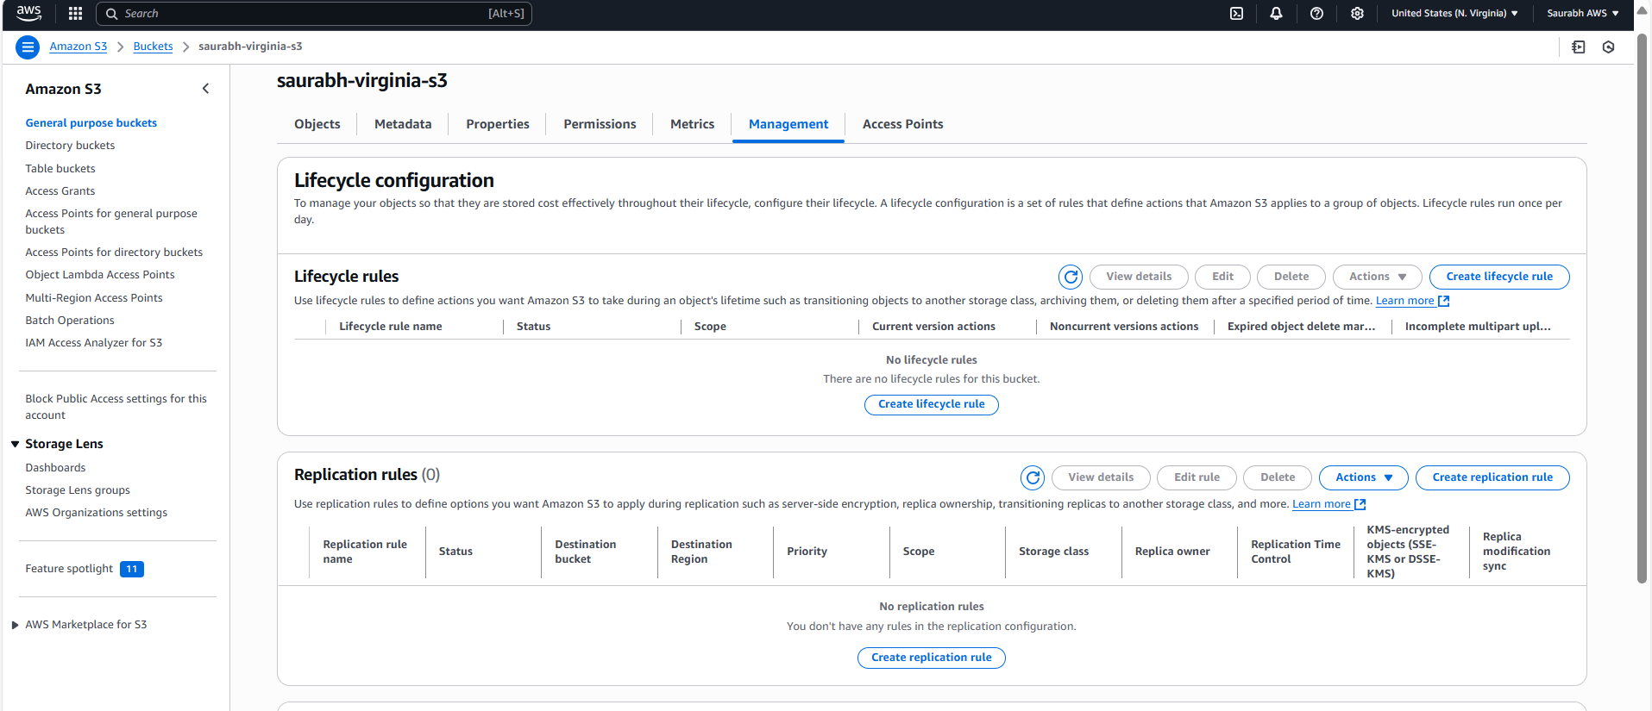

1. Provide configurations:
2. Provide the name to the rule “replication-virginiatomumbai”

1. Provide source and destination details. Create new IAM role. Click on save.

1. Upload the file in Virginia region bucket.

1. Refresh the Mumbai region bucket to check the replication.

1. SRR
2. Create another bucket “Saurabh-virginia-s3-2” in virginia region.

1. Create the replication rule.

1. Upload a file source bucket “Saurabh-virginia-s3-2”

1. File will be replicated in destination file.

